MACKAYE HARBOR WATER DISTRICT BOARD OF COMMISSIONERS MINUTES
REGULAR MEETING - JuLY 20, 2026
Date: | July 20, 2026
Time: | 1:00 PM
Meeting called to order by: | San Olson

Call To Order
The Board of Commissioners for MacKaye Harbor Water District met on July 20th, 2026, at the residence of San Olson - 481 Barlow Bay Rd; San Olson called the meeting to order at 1:08 p.m. and confirmed a quorum.

In attendance
Present were commissioners San Olson and Walt Krumbholz; Manager, Wayne Haefele; and clerk Alice Faulkner.

Regular business

Approval of Minutes
Approval of the June 15 minutes were postponed until the next meeting.

Approval of Vouchers and Payroll
Faulkner distributed the July payroll; no corrections were requested; the payroll was unanimously approved in the amount of $384.00 for a total payroll cost of $520.06.
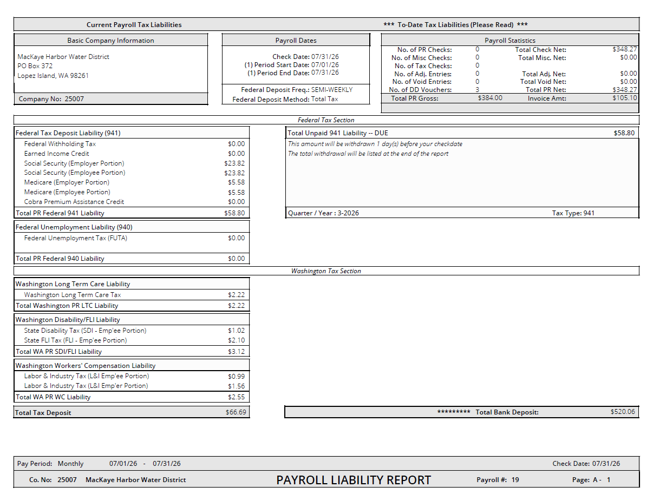

Faulkner distributed the July claims; the July claims were unanimously approved without correction for a total approved amount of $17,923.95.

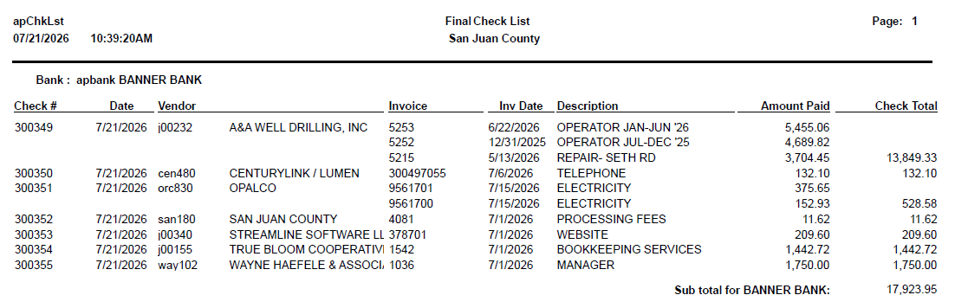

Financial Report
Faulkner reported $1,246.28 in water billings and $124.63 in late fees had been received since the June meeting; total revenue for the period including investments interest came to $1,379.36; year to date total came to $60,865.65; expenditures for the period came to $18,446.10 leaving $3,335.25 in the general fund and $5,100.00 in the investment pool. Faulkner noted the following:
- ~$2,000 in outstanding January water billings from two accounts; Statements to be bundled with July invoices to save postage
- Well drilling invoices still missing January through June 2025; following up with Tricia Arnott from A&A Well Drilling.
- Minutes approval and payroll signing deferred to next meeting (sent too late; not yet read by all)

Manager’s Report
- Haefele reported that, according to Arnott, there had not been any issues with the system.
- OPALCO bill for Salmon Point pump station: $375.65 vs. ~$160 normally (2,500 kWh vs. ~500 kWh)
- Well site electrical bill stayed normal, suggesting not a water/flow issue
- Anomaly occurred between June 15 and July 15 billing cycle
- Possible causes: failing pump motor drawing excess current; unauthorized entry (new generator battery trickle charger ruled out as too small)
- New generator installed recently; one pump motor is new, one is not
- Plan to investigate at Salmon Point after the meeting
- Faulkner will send Meter read spreadsheet to Haefele for review.

Commissioner’s Reports
None

Public Comment
None

Commissioners’ Additions to the Agenda
None

Unfinished Business

Discuss EPA Grant

- Extension confirmed (approved June 12, end of September deadline)
- $14,787.50 fronted by MHWD for WH&A Engineering invoices, not yet reimbursed under the grant
- Advertising costs were added to Phase two budget only, so cannot be included in draws until Phase two is approved
- Draw #27 forms, which include all EPA reimbursable expenses not yet reimbursed, to be sent to Krumbholz for signature and PDF return after the meeting
- Phase two still awaiting EPA approval; all requested revisions submitted, no confirmation of receipt from Amy
- NEPA review items submitted promptly after last meeting; no outstanding items on MHWD end
- Communication with EPA has been poor: Amy Williams unresponsive for months despite multiple emails and calls
- Heather Kahn (Grant Administrator) confirmed extension and forwarded the June 12 email; deferred Phase two questions to Williams
- Extension approval email was sent to Krumbholz on June 12 but never received; he to check email and spam folder.
Haefele reported the following regarding coordination with DOH:
- Raquel (DOH regional contact) has been effectively unavailable for ~18 months
- Maternity leave, additional leave, and now part-time schedule (Mon/Tue/Wed)
- Voicemail still says on maternity leave until July 1; no reply to last week’s email or this morning’s call
- All DOH comments answered thoroughly; no outstanding items on MHWD end
- Cannot progress Phase two design work without DOH feedback
- Plan to escalate to head of Northwest Drinking Water section
- Phone call first, followed by a formal letter
- Update commissioners before next meeting if any response is received

Discuss Progress on Projects Under PFFAP Grant
None

New Business
None

Adjournment
Olson declared the meeting adjourned at 1:55 PM.

Approval of Minutes

________________________________ __________________________________
Commissioner, San Olson District Clerk, Alice Faulkner

